

**High Level Solution**

**Order Service Management & Inventory Management**

**Solution implementation**

**for**

**POC**

**TSAROLABS PRIVATE LIMITED**

Legal Notice and Disclaimer

This document is proprietary to TSAROLABS PRIVATE LIMITED (called onwards as TSAROLABS). It is supplied in confidence and, except for evaluation purposes, should not be disclosed, duplicated or otherwise revealed in whole or in part without the prior written consent of TSAROLABS.

Whilst every care has been taken in preparing this document, the content is subject to formal contract negotiations. All conditions and warranties whether expressed or implied by statute, law or otherwise, are hereby excluded. This document shall not form part of any contract.

This document was prepared on the instructions and information given by TSAROLABS and accordingly no responsibility is accepted for any inaccuracy or error or any action taken or not taken in reliance on this document.

Any comments on, or opinions stated in this document regarding the functional and technical capabilities of any software or other products proposed or referred to in this document, whether or not expressed as being those of TSAROLABS, are based on the information provided by the product vendors to TSAROLABS or provided by TSAROLABS.

**Table of Contents**

1. **Project Overview…………………………………………………………………..4**
2. **Solution Overview…………………………………………………………………5**
   1. Solution Components
3. **PSR model approach………………………………………………………………6**

**4.Order & Service Management (OSM)…………………………………………….6**

**5.Unified Inventory Management (UIM)……………………………………………7**

## **6.**Solution Architecture………………………………………………………………7

### **7.Mobile PSR Model………………………………………………………….………8**

7.1 PS to CFS

7.2 CFS TO RFS

**8.Order Capture……………………………………………………………………..9**

8.1 Order Orchestration

8.2 Design & Assign Resources

**9.Order Flow…………………………………………………………………………10**

**10. OSM Architecture……………………………………………………………….11**

**11.Solution Integration Points………………………………………………………12**

**12.Sample Request……………………………………………………………………13**

# Project Overview

The POC is about creating an end-to-end solution by implementing the RSDOD Architecture.

The solution proposed here involves multiple solution components for creating a Mobile service.

# 2.Solution Overview

The proposed solution uses proven and industry standard COTS products of oracle. OSM shall be used to manage service order, ASAP will manage Activation part, UIM will be responsible to provide unified inventory and BRM will be responsible for billing and invoices.

Oracle UIM is modular and flexible, so it can replace existing inventory systems or work cooperatively (federate) with them. UIM allows access to its service and network asset data through cooperation with a carrier’s other systems. Through integration with other Oracle Communications applications and third-party systems, UIM plays a vital role in service fulfillment.

<Solution in Tsarolabs scope of delivery>

TSAROLABS scope is limited to delivering the following solution components as part of the overall solution.

* OSM COM
* OSM SOM
* UIM

## 2.1 Solution Components

The End-to-End Solution utilizes multiple solution components provided by Oracle.

1. Order & Service Management Central Order Management (OSM COM) by Oracle
2. Order & Service Management Service Order Management (OSM SOM) by Oracle
3. Unified Inventory Management (UIM) by Oracle

|  |  |
| --- | --- |
| **Components** | **Key Functionality** |
| OSM  (Order & Service Management) | * Deploying the Solution Cartridge. * Integration with UIM * Implementing o2acatridge * Implementing OTM for mobile service (Order Transformation manager) * com-som * som-uim |
| UIM  (Unified Inventory Management) | * Manage Resource and Service Inventory * Manage Logical Inventory * Resource/Network capacity utilization and thresholds * Event Enrichment (Physical –logical- Service-Subscriber information for Service Assurance) * Design and Assign (Mobile) * Service fulfillment * Upstream & Downstream Integrations. |

**3.PSR model approach**

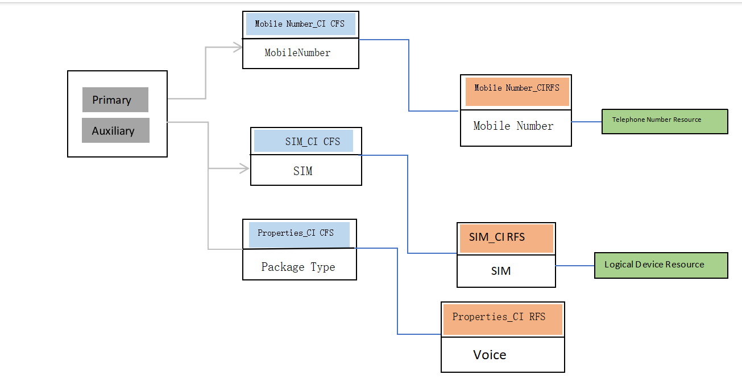

Fig 1.PSR model approach

**4. Order & Service Management (OSM)**

This application manages the end-to-end lifecycle of service requests. OSM manages the actions required to fulfill the orders across provisioning, shipping, inventory, billing, and other fulfillment systems. OSM has two key sub modules COM & SOM.

COM – Central Order Management

COM receives customer orders from CRM. These orders specify the products the customer has requested. COM orchestrates the fulfillment of the customers' orders across other enterprise systems such as billing system, shipping system, fulfillment system and more. COM is responsible for receiving status information from the fulfillment system.

SOM – Service Order Management

SOM is typically part of service fulfillment stack, working with inventory and activation systems to fulfill services in one or more network domains. SOM typically receives an order containing subset of contents from the customer order sent by COM. It manages the fulfillment of services and resources for the order in conjunction with an inventory system for assign-and-design work and an activation system to configure the network devices and applications.

OSM uses three basic steps to process an order:

1. **Create the order.** OSM receives the sales order and creates an order in OSM.
2. **Generate the orchestration plan.** The orchestration plan manages how the processes that fulfill the order run.
3. **Run processes and tasks.** The tasks interact with external systems to complete the order. The processes control how the tasks run.

The activities include many steps such as Service Validation, Order Transformation, Service Order Request, Service Activation and Billing Account Creation. It also includes Order Tracking along with Orchestrating the Activation.

OSM is an order processing system that takes an order as input from a CRM system and manages the fulfillment functions that need to be carried out to complete the order. Fulfillment functions include operations such as assigning a phone number, activating a service on the network, shipping a phone, and running the billing.

OSM coordinates with fulfillment systems that run other applications such as BRM, UIM, and ASAP.

**5.Unified Inventory Management (UIM)**

UIM is a standards-based telecommunications inventory management application that enables to model and manage customers, services, and resources. UIM supports complex business relationships and provides full life-cycle management of services and resources.

## 6. Solution Architecture

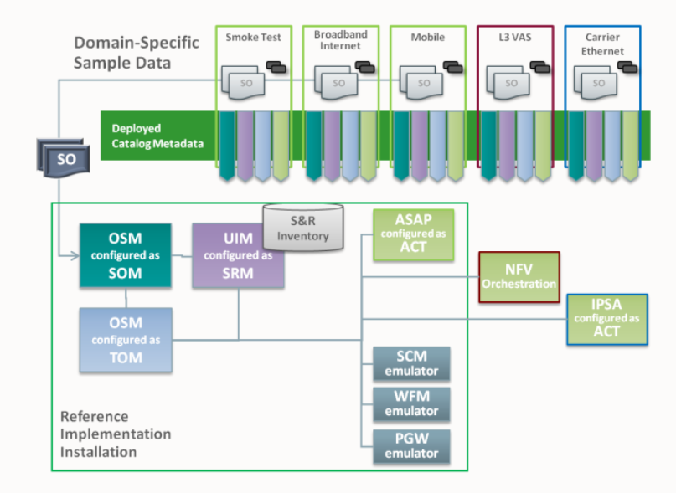

Fig 2.Mobile Flow Architecture.

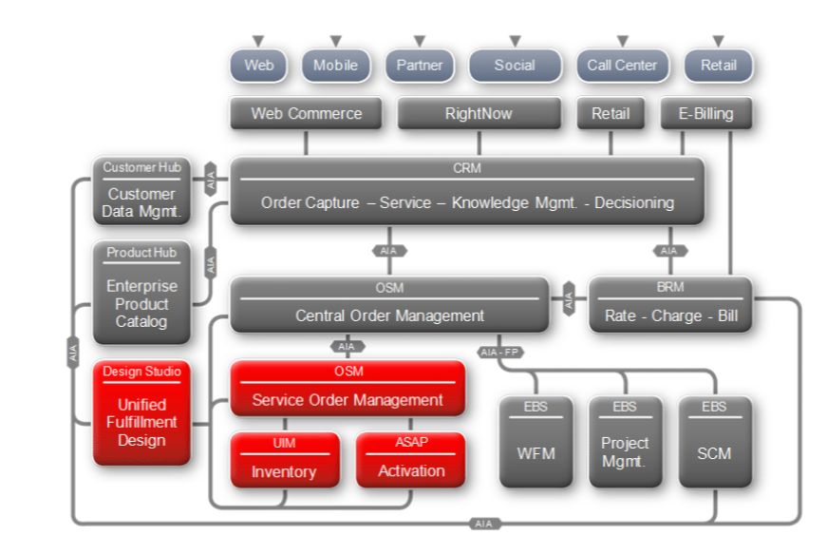

Fig 3.RSDOD Architecture.

### **7. Mobile PSR Model**

7.1 PS to CFS

Customer Facing services

Product specifications

**Mobile CFS Service**

**Mobile PS Service**

Fig 4.PS to CFS

7.2 CFS TO RFS

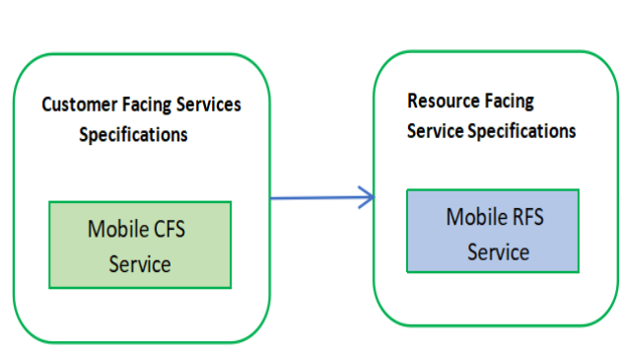

Fig 5.CFS to RFS

### **8. Order Capture**

Orders will be entered and captured in the CRM system.

**8.1 Order Orchestration**

To process an order, OSM will run processes and tasks for a variety of functional areas while interacting with multiple systems. To manage all of the orchestration entities and processes, OSM generates an orchestration plan. The orchestration plan decomposes order items into order components and establishes dependencies between order components and between order items.

Each order has a unique orchestration plan, based on the customer order and the tasks required to complete the order. OSM executes the orchestration plan by running the order's default orchestration process. The orchestration process begins the process of selecting the executable order components to run. As order components run their processes and tasks, the orchestration plan manages their dependencies.

### **8.2 Design & Assign Resources**

The design and assign process completes the transformation from a **customer-facing service** (CFS) to a **resource-facing service** (RFS). A CFS is a representation of the service that the customer purchased. An RFS is how the service is implemented on the network.

The design and assign process works as follows:

* OSM sends a request to UIM to design a service and assign resources.
* Given the customer requirements, the UIM system determines which predefined service configuration is appropriate, and based on that, finds the network resources that are available. The UIM system finds an available device at the customer's location and assigns it to the customer's service.
* The UIM system returns the resources, resource-facing services, and their associated actions to OSM. The UIM system also changes the status of the resources in the inventory.

# **9. Order Flow**

OSM(COM)

UIM

OSM(SOM)

**Business Interactions**

**Service fulfilment Order**

**OTM (products to CFS) Technical Actions**

**Technical Order**

**Activation Done Response**

OSM(TOM)

**Activation Done Response**

**SOM Order Completed Response Services Assigned and Activated**

* The CRM system sends the Sales Order to OSM.
* OSM-COM receives the order. Then it validates the sales order and generates the Orchestration Plan. Below is the representation of Orchestration Plan:
* OSM-COM does the OTM (Order Transformation Manager) mapping from PS (Product Specification) to CFS (Customer Facing Service) i.e., transforms the customer order to service order and sends the Service Order to OSM-SOM.
* OSM-SOM receives the Service Order from COM and does the transformation from CFS into Service Actions.
* OSM-SOM sends the Service Actions to UIM for designing and assigning the resources by using Business Interactions.
* Once OSM-SOM receives the Technical Actions required to activate the services from UIM.
* OSM SOM sends the technical details to OSM-TOM for completing all the actions (SCM, PGW, WFM, ACT).
* Once the services are activated, ASAP sends the response back to OSM SOM.
* OSM-SOM sends update interaction request to UIM for UIM order closure.
* Order gets completed in OSM-SOM and sends the Fulfillment status “completed” to OSM-COM.

# **10. OSM Architecture**

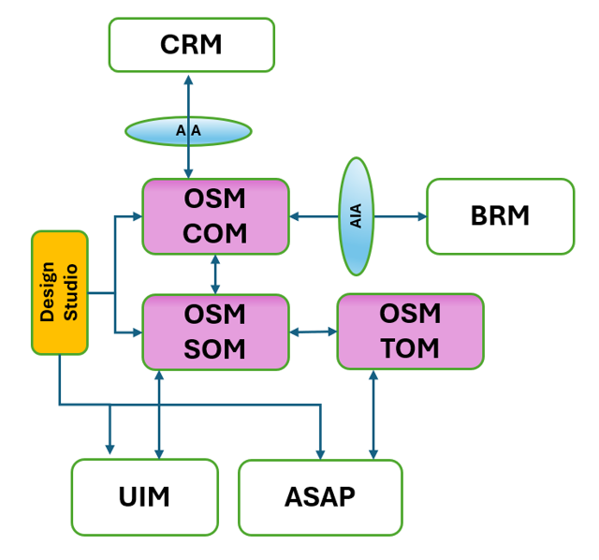

* CRM (3rd Party Solution) is the Order Entry system.
* The Customer Order entered from CRM is pushed to OSM for functional and service fulfillment.
* OSM COM layer takes the customer order received from CRM via DX.
* OSM COM creates the service order and passes it on to OSM SOM layer.
* OSM SOM layer integrates with UIM for service assign and design, performs automated service assign and design functionality.

At the core of the solution is UIM, which will include:

* Service Inventory
* Resource Inventory
* Accurate view of network environment including the availability of physical and logical resources managing the utilization and capacity of the network resources and the relationship between the network resources (both physical & logical), services and customers.
* Both active and passive inventory will be maintained in the UIM across various technology domains.
* UIM will handle design & assign functionality of network resources to satisfy customer service requests and provide a view of assigned resources to external systems such as Service Assurance and performance management.

# **11. Solution Integration Points**

The proposed solution will have several key integration points. These integrations will include:

|  |  |
| --- | --- |
| **UIM and OSM** | **U**IM will integrate with OSM to assign the appropriate resources and provide information about the resource availability.  OSM provides the order management function in NEC architecture. OSM will accept Complex order requests from Unified OSS Console and transforming, decomposing and enriching the orders into multiple service orders. As an example, a single order for a three site VPN broken may be broken into three separate service orders (one for each site) for further processing.  OSM will drive the service order workflow for each service order. The interaction between OSM and UIM will be primarily for assignment of service for custom orders. |
| **UIM and Trouble Ticketing** | Trouble Ticketing Solution will pull network service, resource details and associated customer details from Oracle UIM to populate network trouble ticketing information in the event a network fault or assurance scenario is executed. |
| **UIM & Activation Systems (ASAP)** | The integration between Activation Systems and the Oracle UIM logical inventory platform is provided via UIMs open standards web services API to provide the necessary network service, resource details and associated customer details |

# **12.Sample Requests**

Mobile_capture_BI

